**PROBLEM DOMAIN**

# “Online Roommate finding System”

* 1. **Background to the Problem**
* Online Roommate finding System is an online solution that will help connect people who want to rent or share their rooms with people who are searching room to stay. People who want to stay one day or a few days in a place on an emergency basis but most hotels are costly and those are charges very high. Students when going to another city to study, to manage accommodation they find and face many difficulties. On the other side, some people want to share their room for a little charge or one student/person finds a roommate to share the room but they don’t find out the roommates. There is no available reliable solution. So we want to be the middle man the connection point and build a system that will connect them.
* The root cause of the problem is the unavailability of data or information. The finder has no information about the renter who wants to share or rent his room. Same way renter has no information about the people who want to stay. Safety and security are also big factors.

The problem is important to consider because every day many people and students are facing problems to find out a reliable place to stay but there is no easy solution available.

* 1. **Solution to the Problem**
* To deal with the problem we want to build a system which will connect the renter and houselord or roomlord. In the system we will add feature of search and filter option. By using these search and filter option user can find out the best house and best mate.
* This solution is particularly appropriate to solve the problem because it fulfils both of their requirements.
* Yes, the solution is feasible to meet the business objective.
* The software is specified for the ones who are facing problem to find a room and for the ones who want to share their rooms for rent.
* The purpose of the software is to help connect people who want to rent or share their rooms with people who are searching for a room to stay.
* There are many benefits of using the Online Roommate finding System. If a person goes to an unknown place but doesn’t know where to stay. The person can find a suitable reliable place by using this software. The rent price is affordable and much lesser than the usual hotels. This software is user-friendly so anyone can use it easily. The renter earns a handsome amount just by sharing his room.
* The objectives and goals of the software are to connect anyone to everyone. No one feels alone to go to a new place and get a homie environment.
* There are many many Existing studies available in this problem area. Find Your Roommates — Case Study and Roommate Matching Software Gains Popularity are two examples of them.
* The existing software solutions that are available to solve the problem are Airbnb, Agoda Homes, Booking.com.

2.1 **System Features**: There will be 3 types of user in our software:   
1) Admin 2) User 3) Room provider  
  
The system features of our app areo Sign up o Login o Search o CRUD (create, read, update, delete) o Booking accommodations (including date, check-in time and other details), Inapp messaging, booking notifications, log out.  
  
**2.2 UML Diagrams :**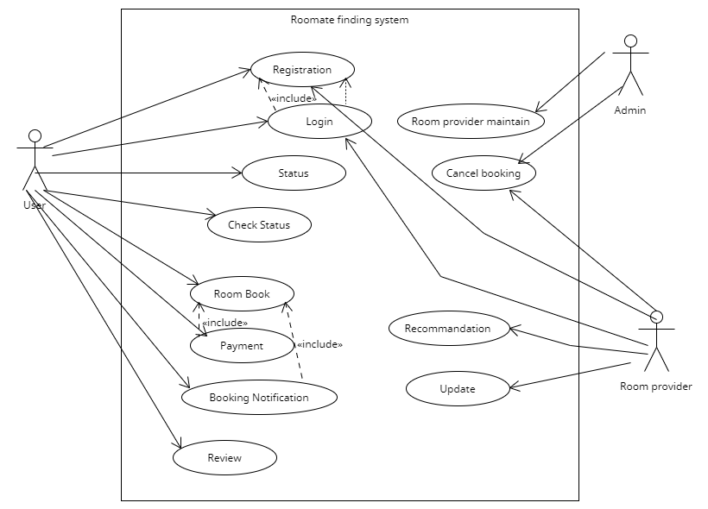

Figure 2.2.1:Use Case Diagram

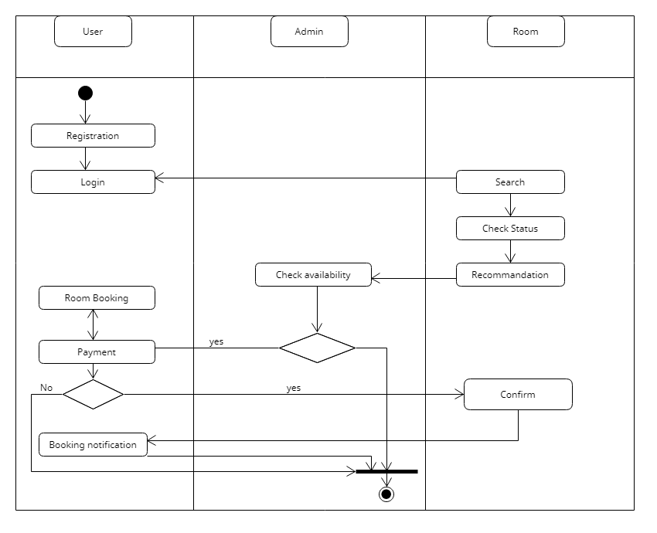

Figure 2.2.2 Activity Diagram

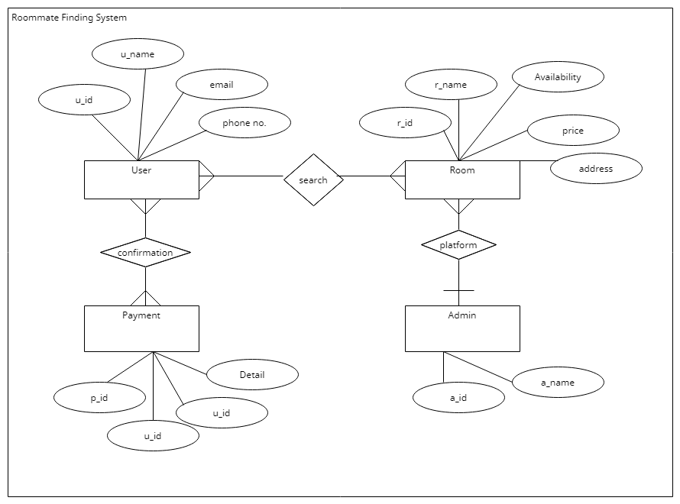

Figure 2.2.3 ER- Diagram **3. SOCIAL IMPACT:**

**Due to some economic reasons many students or people must live with roommates. Now similarly each user has personal preferences or lifestyle choices along with cost constraints. Now our goal is to suggest a group of people who could be potential roommates for a user searching for roommates by satisfying the cost or the budget constraints Sometimes it may possible they can’t find roommate like they prefer to have. There no match with their expectation. There may have issue with habit and cleanliness.. So that there can be difference between online vs. reality. Anyone can stumbling due to lack of awareness.so everyone should be careful . more people aged 25 to 34 years are living with roommates rather than alone — at a rate of 7.4%,**[**Forbes**](http://www.forbes.com/sites/alexandratalty/2015/11/03/skyrocketing-number-of-millennials-living-with-housemates/#fb009a26ae92)**reported. This could be due to lower wages, higher rates of unemployment and higher rates of**[**student debt**](https://mic.com/articles/117644/it-s-official-the-class-of-2015-has-the-most-student-loan-debt-in-history)**.**

**The social impacts of roommate finding system are:**

**1.Women frequently look only for other women as roommates (excluding men), but some are often look for either gender in their search try to humiliate them. From this technology they can find the right one.**

**2 .May have a higher market valuation than any traditional lodging company  and has led to a major change in the traditional accommodation system.**

**3.Making sure collect every members data so if there anything happened they can take necessary decisions.**

**4.Thus it is a online platform people may have not trust this site. It’s a safe place because making sure about the identity.**

5. Happiness with our living environment can be greatly affected by our roommate relationships.

**6. The main advantages cost savings for accommodation, the generation of more authentic local experiences and better relations with the hosts.**

7. Help to get a shelter that matches one’s preference, budget, interest and proximity

**8. By living together it increase social network.**

**9. It may help to remove homesickness.**

**10. Can help each other if needed.**

**11. Its impact on the tourism industry are so many.**

**12. people can gather good communication skill by living together.**

**13. Consumers are afraid of identity theft and credit card fraud, as these are the usual hacks that consumers may experience when they share information on an online site. Should be concern about safety.**

**14. It may complicated process for the adults people which are not used to use the online platform. Should cncern about the process and always in service to help if needed.**

**15. Provide a satisfied system to transfer rent.**

**16 . They may concern about safety.**

**4. Development plan:**

As our application is mainly focusing on customer needs, we will use an agile model for our project development. Because this model is designed to put customer needs first. It makes any application or software highly responsive to customer feedback. Agile seeks to release software cycles quickly, to respond to a changing market. This requires a strong team with excellent communication. Software Development Life Cycle is the application of standard business practices to building software applications.

It’s typically divided into six to eight steps:

**Planning, Requirements and feasibility analysis, Design, Development, Testing, Deploy, Maintain.**

**1. Planning:** In the Planning phase, our developers will evaluate the terms of the project. During the meeting, we'll talk about our concept. We'll brainstorm and come up with a plan for what we'll do next during our meeting. As a result, we'll need at least one week to meet and brainstorm, which will take almost two weeks. This includes calculating labor and material costs, creating a timetable with target goals, and creating the project’s teams. It can also include feedback from stakeholders. Stakeholders are anyone who stands to benefit from our application. Planning should clearly define the scope and purpose of our application. It plots the course and provisions the team to effectively create the application.this process can take 1 week.

**2. Requirements and feasibility analysis:**Requirements and feasibility analysis makes detailed estimation and planning complete.We will also collect requirements from people, lawyers, and clients in this section because they will be the system's users. So, by gathering certain requirements through the use of questionnaires, we can obtain a sense of how our system will work. We'll need at least one week to get those prerequisites. Also, we must decide whether a demand is necessary or not, which feature will be developed, and conduct brainstorming to come up with the best solution. It looks at whether the application we want to build is viable for our requirements or calls for changes before design and development are in full swing.These can help us to get a more viable and cost-efficient product in the long run. we'll need at least one week to meet and brainstorm, or maybe two weeks.

3. **Design:** The Design phase models the way a software application will work. Some aspects of the design include:

Architecture – Specifies programming language, industry practices, overall design, and use of any templates or boilerplate.

User Interface – Defines the ways customers interact with the software, and how the software responds to input.   
  
Platforms – Defines the platforms on which the software will run, such as Apple, Android, Windows version, Linux, or even gaming consoles

Programming – Not just the programming language, but including methods of solving problems and performing tasks in the application

Communications – Defines the methods that the application can communicate with other assets, such as a central server or other instances of the application

Security – Defines the measures taken to secure the application, and may include SSL traffic encryption, password protection, and secure storage of user credentialsPrototyping can be a part of the Design phase. A prototype is like one of the early versions of software in the Iterative software development model. It demonstrates a basic idea of how the application looks and works. This “hands-on” design can be shown to stakeholders. We can use feedback to improve the application. It’s less expensive to change the prototype phase than to rewrite code to make a change in the development phase. Create throwaway prototypes as quickly and cheaply as possible. Invest the minimum amount of effort that will answer questions or resolve requirements uncertainties.We should not prototype requirements that you already understand, except to explore design alternatives.Prototyping is for a basic visualization of the software not replacement of written requirements.Designing can take upto 3 weeks.

4. **Development**: This is the actual writing of the program. A small project might be written by a single developer, while a large project might be broken up and worked by several teams. We will use an Access Control or Source Code Management application in this phase. These systems help developers track changes to the code. They also help ensure compatibility between different team projects and to make sure target goals are being met.. As a result, we'll attempt to complete our coding portion in five weeks.

**5. Testing:** We'll run a series of tests to see if our system is up to par. The testing procedure will include both white box and black box testing. Testing for regression and acceptance is also a part of the procedure. We will properly test the system. This exemplifies how well our system works. After we've finished coding, we can start testing. We can begin testing after the coding portion of the project has been completed for two weeks. We are going to perform **Unit testing** and **Integration testing** alongside with the system testing. Unit testing will be performed by the developers. We must ensure that the system functions correctly during the testing phase. As a result, a significant quantity of testing is required. If we find an error, we must correct it. As a result, we'll need at least 2 to 3 weeks to complete the testing phase.

**6. Implementation and deployment:** In the deployment phase, we will make our application available to users. It can also be called a pre-launch testing so that we can decide our application is ready to move into production. It will define how our application should go before live operation.For this stage we may need less than 7 days.

7. **Operations and maintenance:** In this phase, the development cycle is almost finished. Our application will be rolled out for live operation and will be used by our customer. They may discover bugs that weren’t found during testing. That is why we will maintain the development cycle by assigning some resources or we can sign a software maintenance agreement with our development team or a third party. Under this agreement, we will set forth what parts of our application should be maintained, upkeep activities, liabilities, and more. For maintenance we may need 1 to 2 weeks.

**Project Schedule**

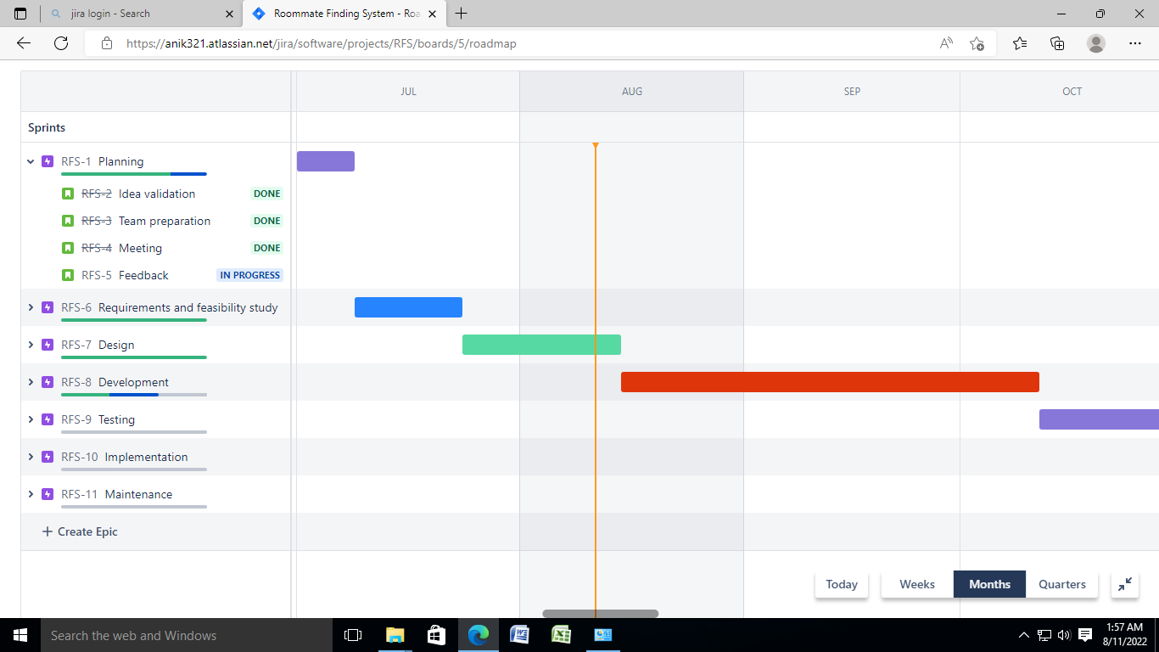

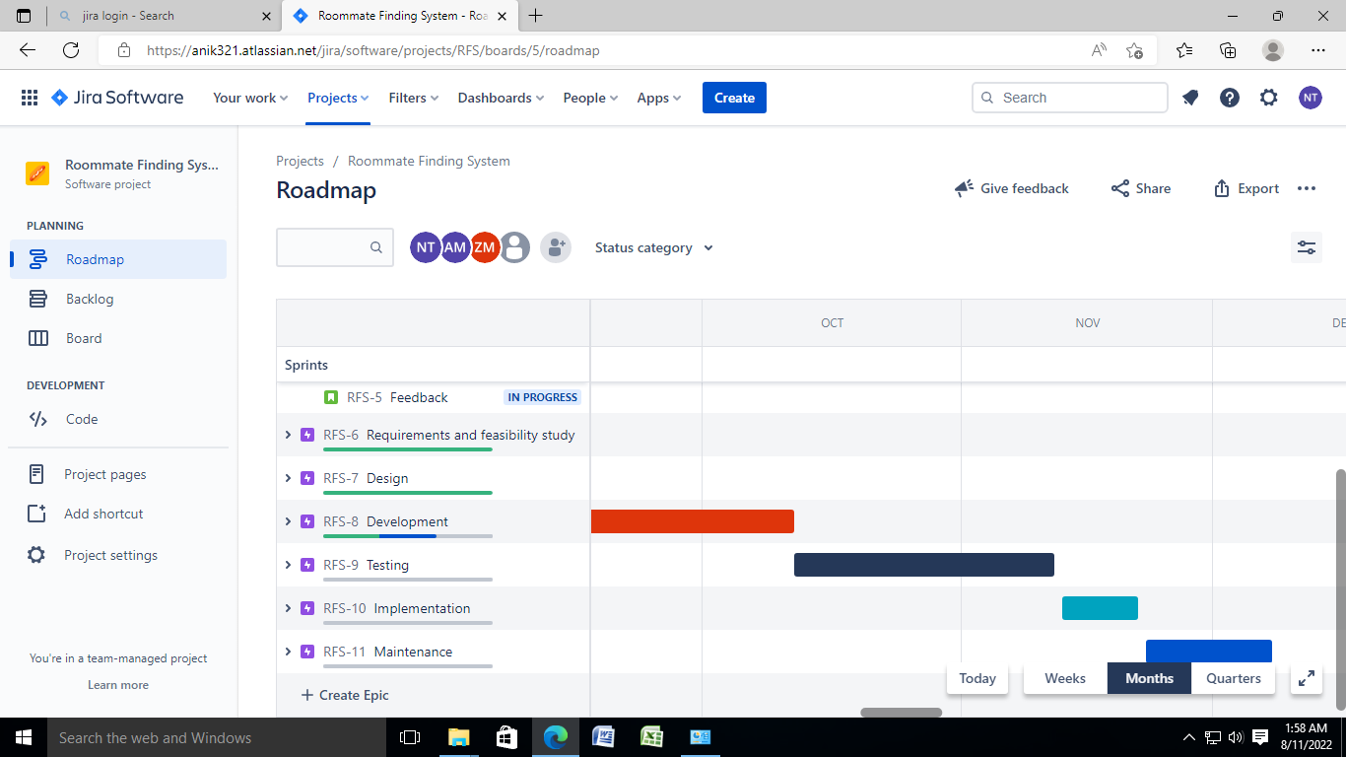

**5.Marketing Plan**

After building the software or system, We have to make a proper marketing plan to familiarize the software with the people. Marketing plans play a great role to boost in sales. There are many marketing approaches available which we can follow. Traditional and Digital Marketing is one of the popular branches of Marketing. Nowadays Digital Marketing is getting more popular than the traditional approaches of marketing. Marketing plans can be Short-term, long-term and Continuous plan. Describe these plans below:

**Short Term Marketing Plan:**

The objectives Short-term marketing planning is to reach a larger audience and about generating sales in the short term. Its a time period basically 1 year or less than that. In short-term marketing, it is difficult to reach out to a target audience and generates leads from them. So the best way is to go the vast people in a short time, there is no alternative than Advertisement. Run Tv ads in the time of World cup, big tournaments and in the break time of popular tv shows is a good approach. Evlay was an E-commerce company that got huge public attention after its launch because of its massive advertisement. So In Short Term Marketing Plan massive advertisement will be the best approach for our services.

**Long Term Marketing Plan:**

Long-term marketing plan is a strategy where Long-term marketing activities help establish brand awareness and trustworthiness. In Long-term marketing focus on the big picture and work for future goals. In Long-term marketing

Plans first we need to find out our target audience to whom we want to approach.

Then we advertise our services among the target audience. We can use Google ads, Facebook ads, Youtube ads to promote our services. It also helps to generate leads. We can also launch campaigns or events to promote our services. Long-term marketing plans create our brand value among the people and brands/service value will grow eventually.

**Continuous Marketing Plan:**

Continuous marketing is a strategy in which the consumers of a good or service are continuously reminded of its need. “Coca-Cola” is a big giant company, its brand value is established everywhere. But Coca-Cola didn’t stop its advertisements. It Continuously marketing by showing ads and reminding the consumers about its need. Like Coca-cola, we can also follow this Continuous marketing approach and reminding people about our services. Continuous marketing helps boost our business and gives Continuous grow. People who buy our services, register our sites or visited our site/page, target that audience and show them our ads frequently. It has high probability that those people buy our services.

**10. References :**• **https://relevant.software/blog/software-development-process/?fbclid=IwAR377mQkN9oYwxVE2frpXHLf9EICSHH-xM_29h0KeQGi5l88rtzoVmsLsuQ**• **https://phoenixnap.com/blog/software-development-life-cycle?fbclid=IwAR2K-2xx2GaBzfwtofsMw_bi1nbhMxO4cGiPpCazf4NhwZ5YxzxhL_9SkTw**

•**https://www.umlet.com/**• [**https://www.geeksforgeeks.org/cost-benefit-analysis/**](https://www.geeksforgeeks.org/cost-benefit-analysis/)•**https://www.perfecto.io/resources/types-of-testing**